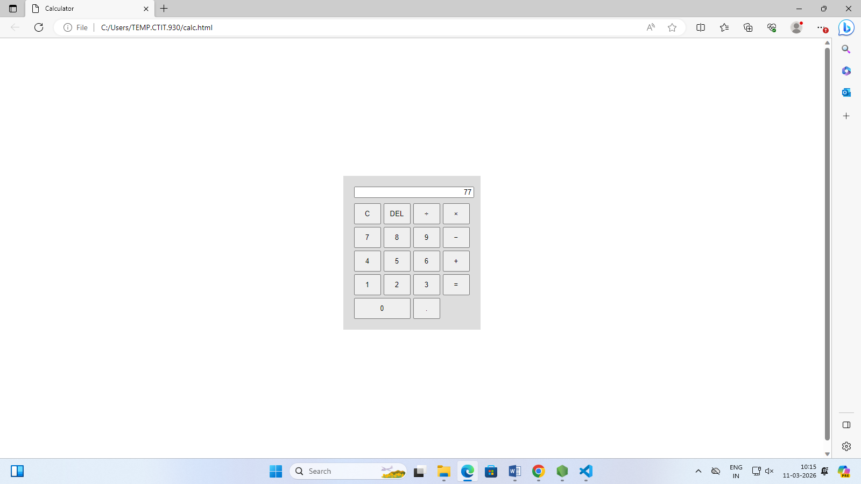

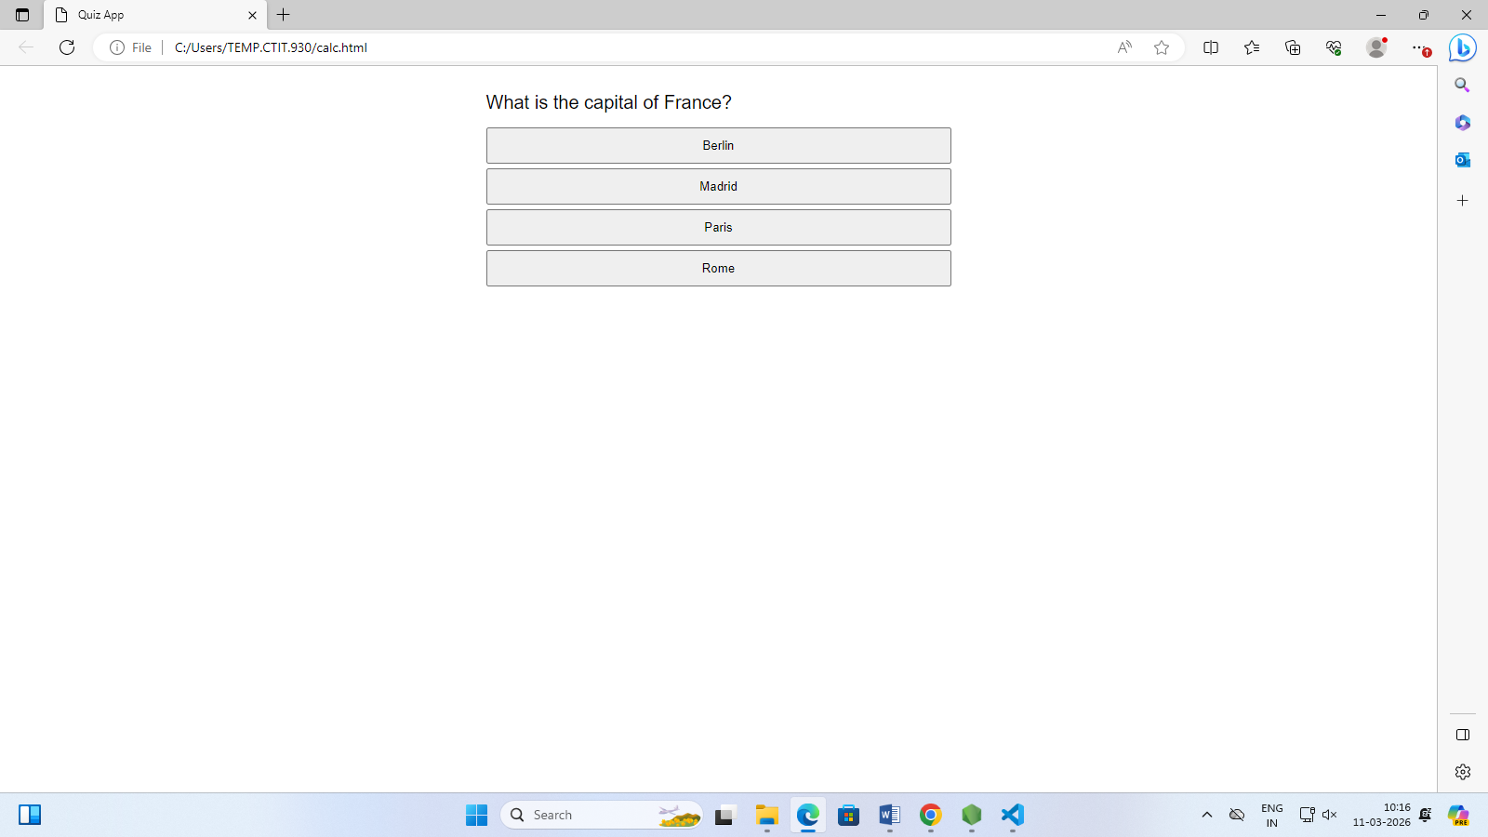



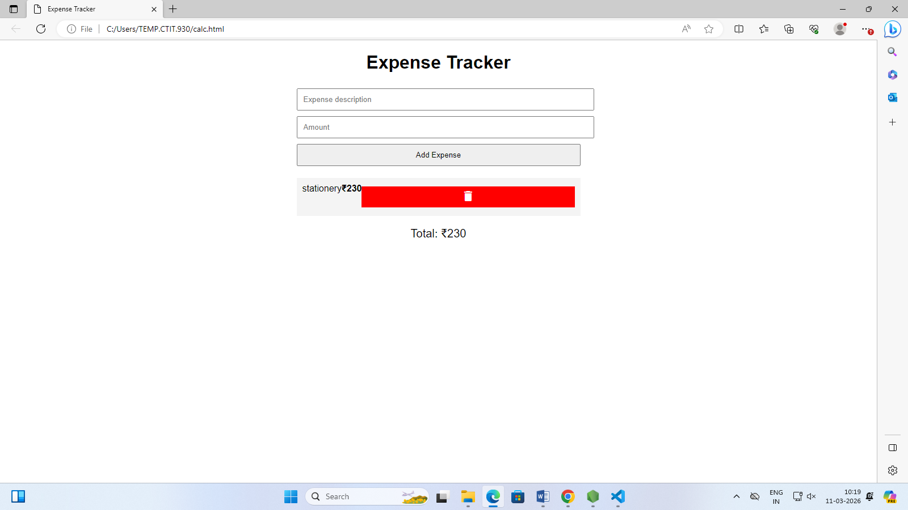



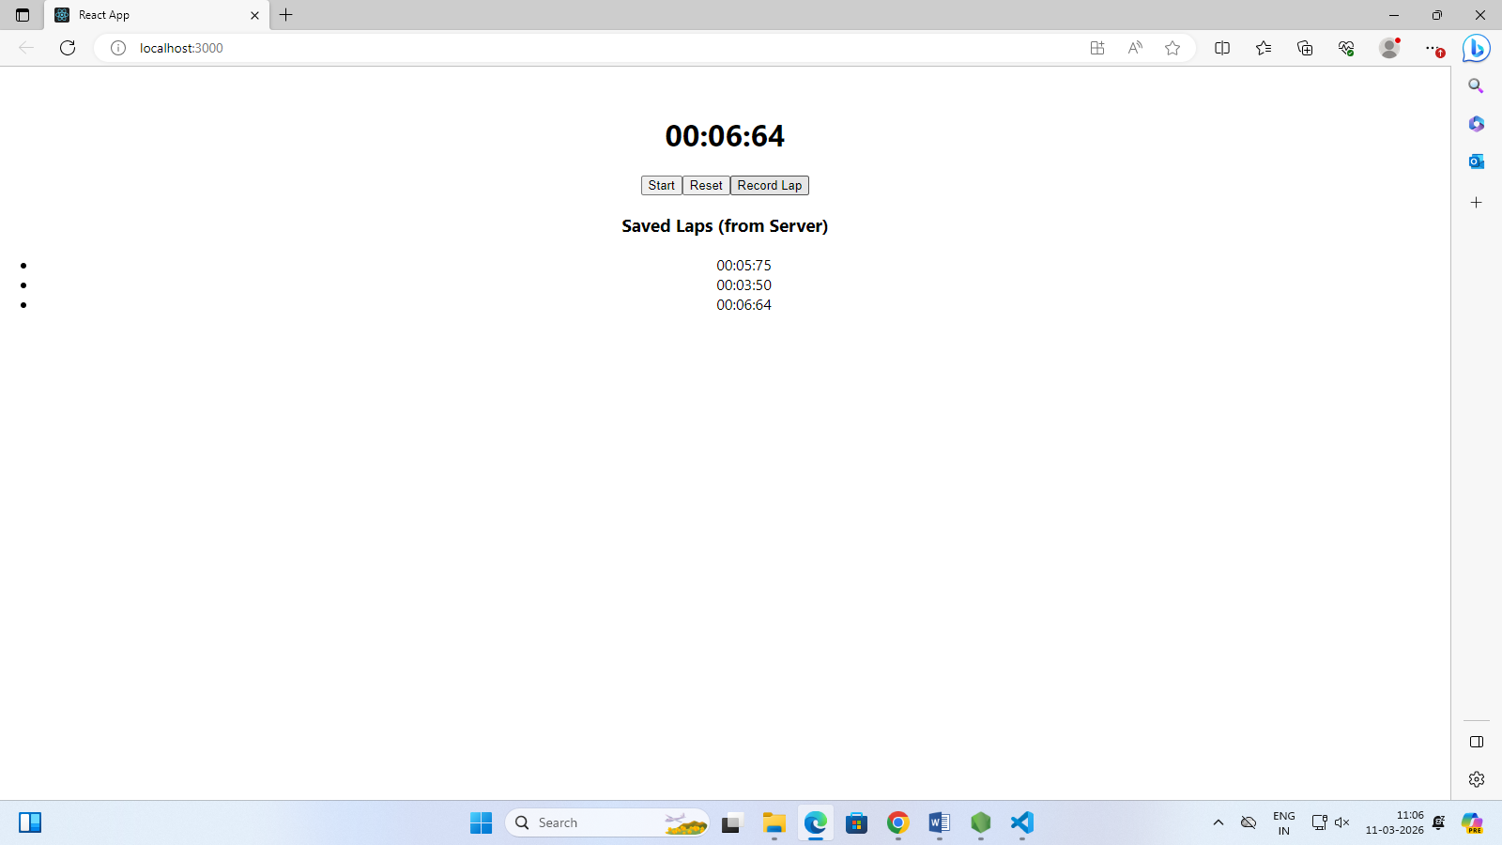
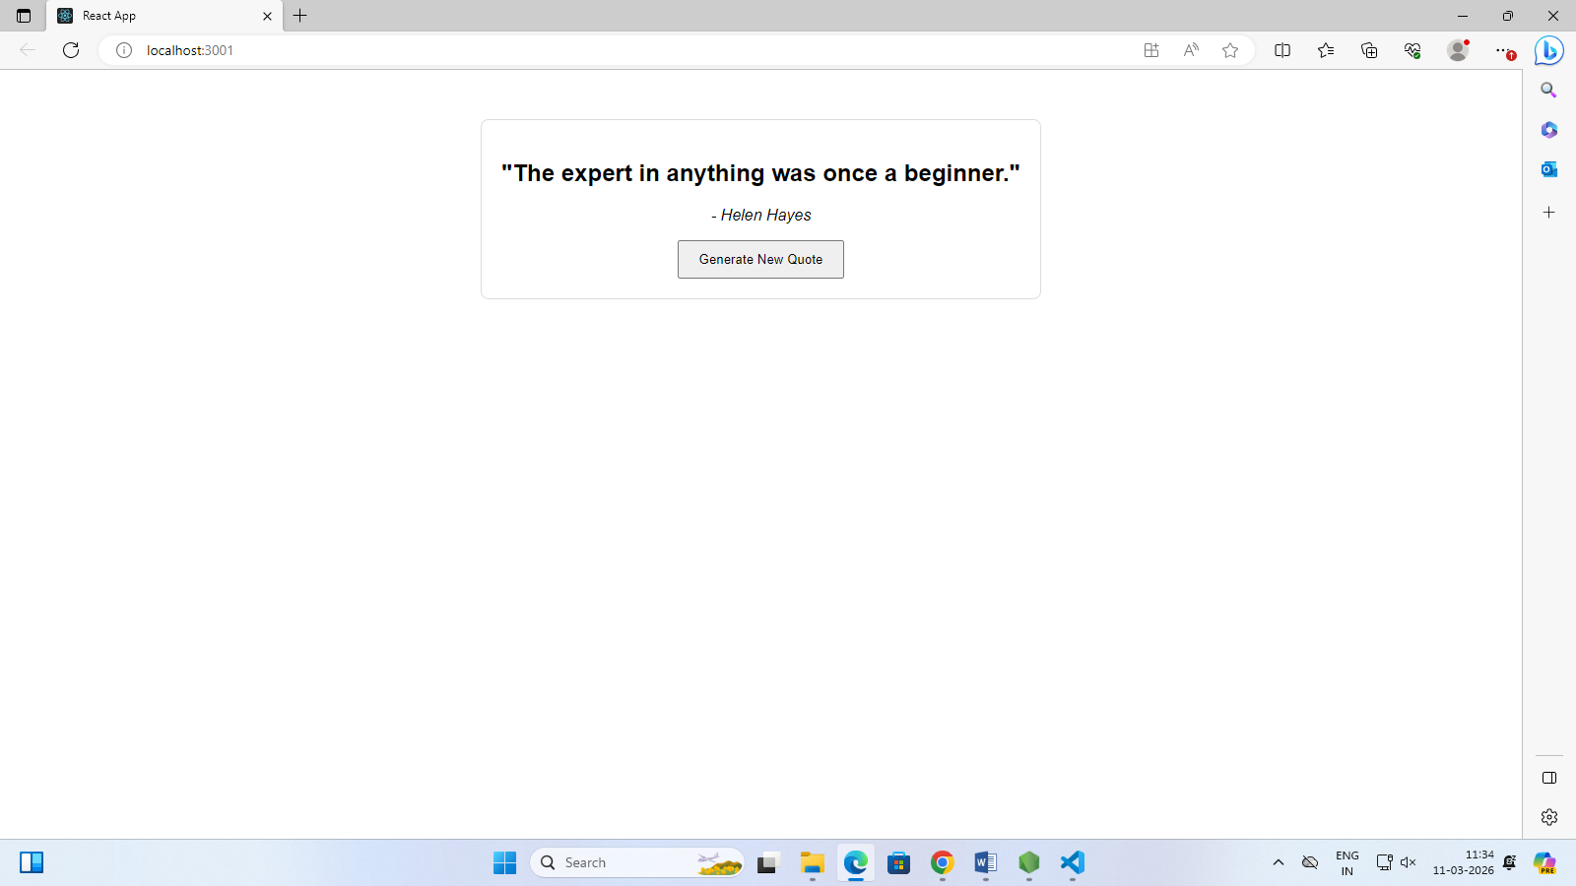

{
name: 'Aron',
student_id: '23UCIT101',
major: 'Information Technology',
gpa: Double('3.8')
}
{
name: 'Arun',
student_id: '23UCIT001',
major: 'Information Technology',
gpa: NumberInt('9')
}
{
name: 'Dinesh',
student_id: '23UCIT012',
major: 'Mathematics',
gpa: Double('8.5')
}

{
acknowledged: true,
deletedCount: NumberInt('1')
}

